

G H RAISONI COLLEGE OF ENGINEERING & MANAGEMENT, WAGHOLI, PUNE
(An Empowered Autonomous Institute, Affiliated to Savitribai Phule Pune University,
Approved by AICT. New Delhi and Recognized by Govt. of Maharashtra.
NAAC ACCREDIATED A+ Grade)

Department of Information Technology

TAE-2(Project Based Learning)

Subject: Object Oriented Programming 23UITPCL2302

“Raisoni parking billing system”

Academic Year 2026-27 Semester-III

G H RAISONI COLLEGE OF ENGINEERING & MANAGEMENT, WAGHOLI, PUNE
(An Empowered Autonomous Institute, Affiliated to Savitribai Phule Pune University,
Approved by AICT. New Delhi and Recognized by Govt. of Maharashtra.
NAAC ACCREDIATED A+ Grade)

Department of Information Technology Academic Year 2026-27

Semester-III

Guided By:-
Prof. Priya Waghmare

Submitted by:
- 25IT62 Jayesh Desale
- 25IT65 Jitesh Salunke
- 25IT76 Krishna Shelke

INDEX

Sr. No | TITLE | Page No
1. | Input/Source Code with inheritance and file handling | 4-5
2. | Output/ Results | 6
3. | Conclusion | 6
4. | References | 7
5. | Githublink | 7

Source Code:

#include <iostream>
#include <fstream>
using namespace std;

class Vehicle {
public:
string vehicleNumber;
string ownerName;
int hours;

public:
void input() {
cout << "\nEnter Vehicle Number: ";
cin >> vehicleNumber;
cout << "Enter Owner Name: ";
cin >> ownerName;
cout << "Enter Parking Hours: ";
cin >> hours;
}
};

class bike:public Vehicle{
public:
int bikebill(){
return hours * 20;
}
public:
void display(){
cout<<"--- Bike Parking ---"<<endl;
cout<<"Vehicle number is: "<<vehicleNumber<<endl;
cout<<"Owner name is: "<<ownerName<<endl;
cout<<"Parking hours is: "<<hours<<endl;
cout<<"Rate for bike is: Rs. 20/hour"<<endl;
cout<<"total Bill of bike is: "<<bikebill()<<endl;
}
};

class car:public Vehicle{
public:
int carbill(){
return hours * 40;
}

public:
void display(){
cout<<"--- Car Parking ---"<<endl;
cout<<"Vehicle number is: "<<vehicleNumber<<endl;
cout<<"Owner name is: "<<ownerName<<endl;
cout<<"Parking hours is: "<<hours<<endl;
cout<<"Rate for cars is: Rs. 40/hour"<<endl;
cout<<"total Bill of bike is: "<<carbill()<<endl;
}
};

int main(){
car C;
bike B;
B.input();
B.display();
C.input();
C.display();

ofstream file("parking_records.txt", ios::app);
cout<<"Bike Records"<<endl;
file << "Vehicle Number: " << B.vehicleNumber << endl;
file << "Owner Name: " << B.ownerName << endl;
file << "Vehicle Type: Bike" << endl;
file << "Parking Hours: " << B.hours << endl;
file << "Total Bill: Rs. " << B.bikebill() << endl;
file << "-----------------------------" << endl;

cout<<"Car Records"<<endl;
file << "Vehicle Number: " << C.vehicleNumber << endl;
file << "Owner Name: " << C.ownerName << endl;
file << "Vehicle Type: Car" << endl;
file << "Parking Hours: " << C.hours << endl;
file << "Total Bill: Rs. " << C.carbill() << endl;
file << "-----------------------------" << endl;
file.close();

cout << "\nRecords saved successfully in parking_records.txt";
return 0;
}

Output:

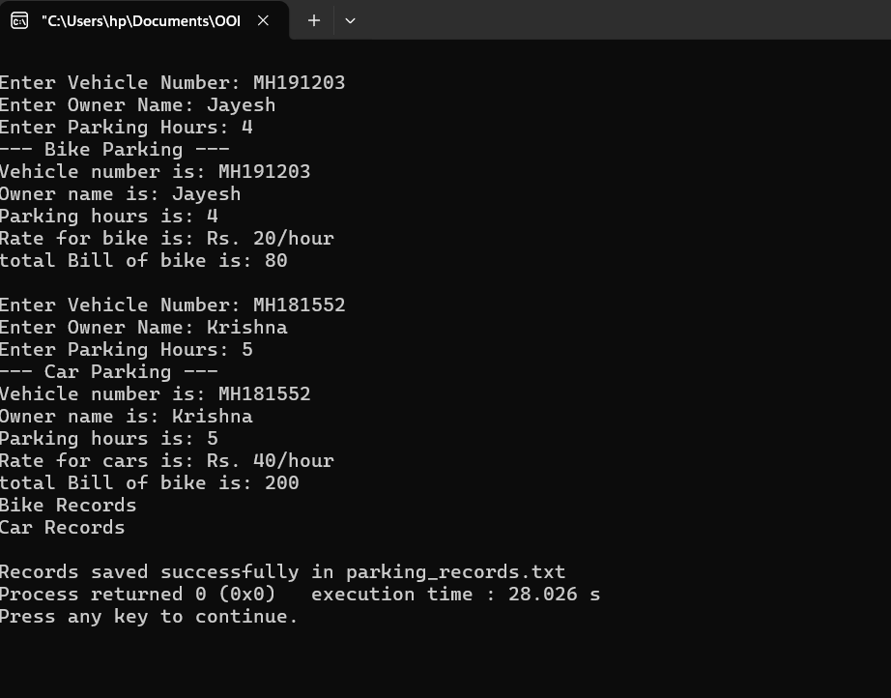

Vehicle Number: MH191203
Owner Name: Jayesh
Vehicle Type: Bike
Parking Hours: 4
Total Bill: Rs. 80
-----------------------------
Vehicle Number: MH181552
Owner Name: Krishna
Vehicle Type: Car
Parking Hours: 5
Total Bill: Rs. 200
-----------------------------

10.References
  - https://pmc.ncbi.nlm.nih.gov/articles/PMC8141779/
  - https://doi.org/10.1016/j.geits.2025.100293
  - https://doi.org/10.1016/j.trpro.2023.11.920
  - https://doi.org/10.1016/j.scs.2019.101608

Github/Kaggel link:-

. Jayesh Desale-> https://github.com/jayeshdesale15/Parking-Billing-System

